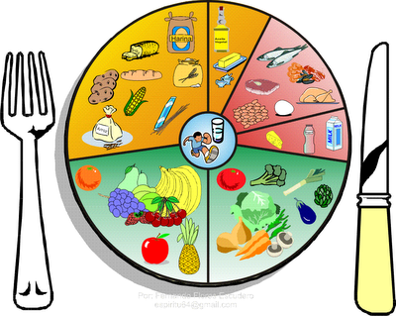
Menu February 15th – 19th

Monday
Mac & Cheese $3.00
Buns $.50
Cheese Melts $2.00
Tuesday
Tuna Melts $2.00
Garlic Bread $.50
Caesar Salad $1.50

Wednesday
Chili $3.00
Buns $.50
Chicken Noodle Soup $2.00

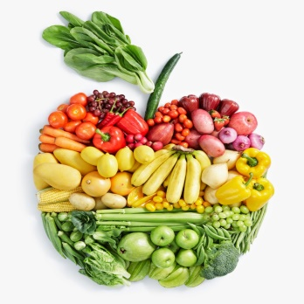
Thursday
PAC LUNCH DAY
PRE-ORDERED
Chicken Noodle Soup $2.00

Friday
Pizza Melts $2.00
Caesar Salad $1.50
Garlic Bread $.50

Items available every day:
Fruit Salad $1.50
Veggies and Dip $1.50
Milk $1.00
Chocolate Milk $1.00
Juice $1.00
Water $1.00

