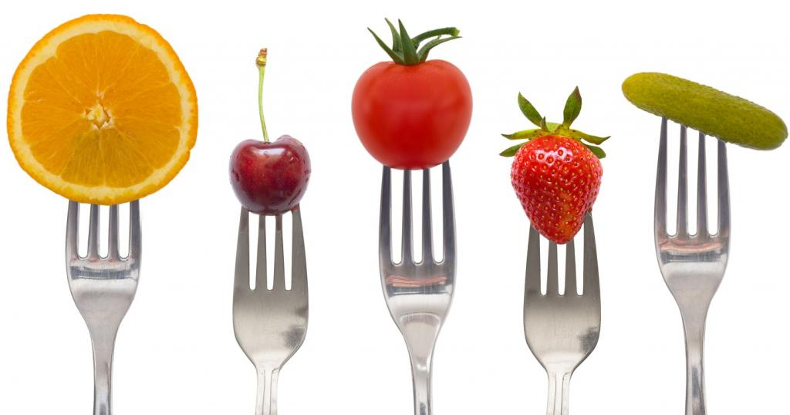
Menu February 1st – 5th

Monday
Mac and Cheese $3.00
Buns $.50
Cheese Melts $2.00

Tuesday
Tuna Melts $2.00
Garlic Bread $.50
Caesar Salad $1.50

Wednesday
Chili $3.00
Buns $.50
Chicken Noodle Soup $2.00

Thursday
Taco Salad $3.00
Cheese melts $2.00
Buns $.50

Friday
Pizza Melts $2.00
Caesar Salad $1.50
Garlic Bread $.50

Items available every day:
Fruit Salad $1.50
Veggies and Dip $1.50
Milk $1.00
Chocolate Milk $1.00
Juice $1.00
Water $1.00

