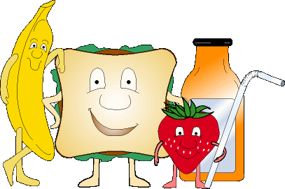
Menu March 1st – 4th

Monday

PRO D DAY
NO SCHOOL

Tuesday
Mac & Cheese $3.00
Buns $.50
Cheese Melts $2.00

Wednesday
Taco Salad $3.00
Garlic Bread $.50
Chicken Noodle Soup $2.00

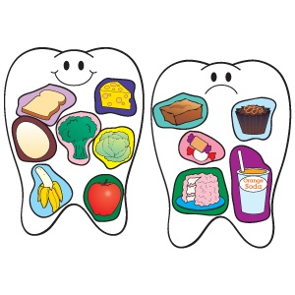

Thursday
Pancakes and Sausage $3.00
Chicken Noodle Soup $2.00
Buns $.50

Friday
Pizza Melts $2.00
Caesar Salad $1.50
Garlic Bread $.50

Items available every day:
Fruit Salad $1.50
Veggies and Dip $1.50
Milk $1.00
Chocolate Milk $1.00
Juice $1.00
Water $1.00

