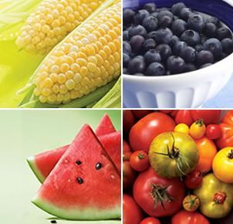
Menu May 30th – June 3rd

Monday
Mac & Cheese $3.00
Buns $.50
Cheese Melts $2.00

Tuesday
Tuna Melts $2.00
Garlic Bread $.50
Caesar Salad $1.50

Wednesday
Chili $3.00
Buns $.50
Chicken Noodle Soup $2.00

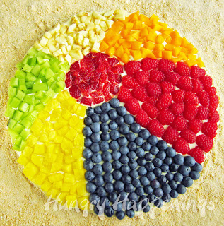

Thursday
PIZZA!
GR.6 GRAD FUNDRAISER
PRE-ORDERED

Friday
Chicken Quesadilla $2.00
Greek Salad $1.50
Garlic Bread $.50

Items available every day:
Fruit Salad $1.50
Veggies and Dip $1.50
Milk $1.00
Chocolate Milk $1.00
Juice $1.00
Water $1.00

